Bain Case Interview Guide
Meta description: WSG founder Stephen Turban breaks down the Bain case interview: both rounds, a worked case with the math, the answer-first close, and a four-week prep plan.

A friend from my year at Harvard, call him Theo, cased well for forty minutes of his Bain final round and lost the offer in the last two. Clean structure, no math slips, a sharp catch on the second exhibit. Then the partner said, "The CEO just walked in. What do you tell her?" Theo started from the top: his structure again, the exhibits again, and a recommendation about three minutes later, as the partner was already reaching for her notebook. The feedback came back through the recruiter a week later: strong analysis, no answer. That is the Bain case interview in one story. The analysis gets you to the final. The close decides it.

I'm Stephen Turban. I went through McKinsey's on-cycle recruiting myself and now run WSG, where we coach students into all three MBB firms, so I've watched Bain's process up close for years, from the candidate's side and then the coach's side. The student who showed me the fix for Theo's mistake was Nadia, who came to WSG a few cycles later having never cased before. She practiced the close as its own drill, apart from full cases, until she could give an answer in four sentences from any point in a case. Her final-round partner stopped her case at the 25-minute mark and asked for the recommendation. She gave it, with a number and a risk attached, and got the offer.

This guide is the version of Bain prep I'd hand both of them. Every structural fact in it is checked against bain.com as of October 1, 2026: the digital assessment, the two interview rounds, Bain's two published practice cases, and the sophomore programs by their current names. Then it goes deeper than the firm's own pages do, with a full first-round case worked with the math, a weak close and a strong close side by side, the written case step by step, the Summer 2028 calendar, and a four-week plan.

How many rounds is the Bain case interview?
Two interview rounds, after an online screen. Bain's interviewing pages say a consulting application typically consists of "a digital assessment and then case interview(s)." The digital assessment runs 30 to 40 minutes through Sova or TestGorilla. Round one is two interviews of roughly 40 minutes with consultants or managers, each mixing a case with some conversation about your experience. The final round is two to three interviews of 40 to 60 minutes with senior managers and partners, where the experience questions carry more weight and a few offices add a written case [VERIFY: round lengths and the written case vary by office; confirm with your recruiter]. The Bain case interview is two rounds of live cases after a 30 to 40 minute digital assessment, and the final round is where fit and the close carry the most weight.

Is the Bain case interview candidate-led?
Partly, and the label matters less than the behavior. Bain's reputation is for open, candidate-led cases where you set the structure and ask for the data you want, and the partner round still feels that way. But Bain also says on its careers site that it gives "all candidates the same questions for each role to reduce bias," and candidates describe a first round built on preset exhibits that every applicant sees in the same order [VERIFY: current round-one format reports]. So in round one you still open with your own structure and your own hypothesis, but the interviewer will steer you to fixed exhibits whether or not you ask for them. Treat every Bain case as candidate-led in your behavior and interviewer-led in its exhibits, and you'll be ready for both rounds.

1. Bain's hiring process has four steps, and the firm describes most of them
Start with what Bain itself says, because the firm says more than its rivals. Its hiring process page walks through an application review, a possible recruiter call, "several rounds of interviews," a case interview for roles that use one, and this line: "After each interview, you'll learn exactly how it went."

The four steps for an undergraduate Associate Consultant Intern (ACI) or Associate Consultant (AC) candidate:

- Application. A resume (Bain asks for Word or PDF), your education history, work experience, and relevant test scores. Cover letters are requested at many offices; check your school's Bain page rather than assuming either way [VERIFY: cover letter requirement by office].
- Digital assessment. An email tells you whether your role uses Sova or TestGorilla. It takes about 30 to 40 minutes and tests problem solving, communication, and analytical skills, in Bain's own words. Section 2 covers it.
- Round one. Two interviews, back to back, usually with consultants, managers, or senior managers. Some offices put a few experience questions at the start of each case; others make one of the two sessions a standalone behavioral interview [VERIFY: varies by office].
- Final round. Two to three interviews with senior managers and partners. Cases run longer and feel more like a live engagement. Experience questions go deeper. Some offices outside the US add a written case (section 8). Decisions typically come within one to two weeks [VERIFY: timing reports from recent cycles].

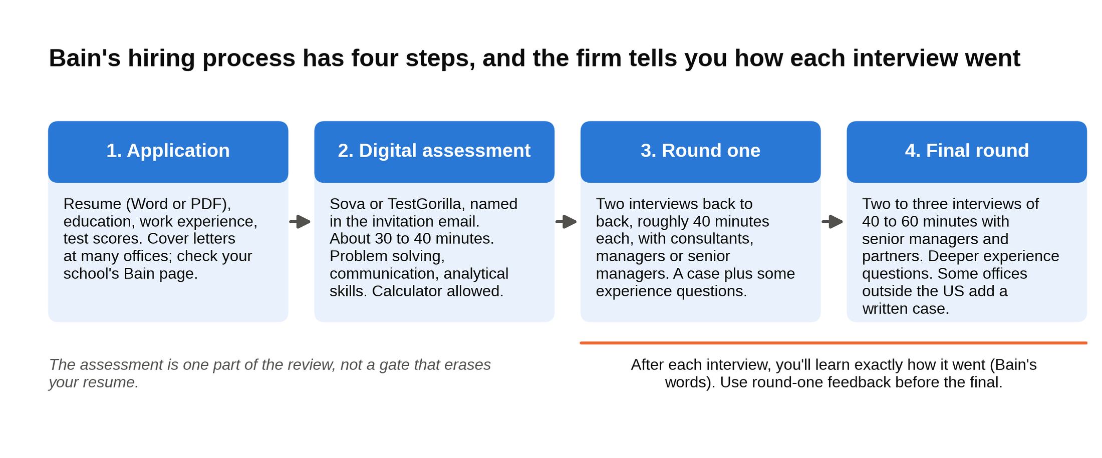
Bain's four steps in order, and the firm tells you how each interview went before the next one.

Two things about that list are easy to miss. Bain gives candidates feedback after each interview, so a final-round candidate can fix the exact thing round one flagged. Use it. Second, the assessment is positioned as "one part of the review process," not as a gate that erases your resume if you have a bad morning. That changes how much time it deserves, which is the next section.

Bain publishes its process, its assessment vendors, and two graded practice cases, so read bain.com before you read any prep site. If a prep site and bain.com disagree, bain.com wins.

2. The digital assessment is one input, so prepare for a week and move on
Bain's assessment page is unusually direct about what the test is. Depending on your role and office, you'll take either the Sova assessment or the TestGorilla assessment, and the invitation email names which. Both run about 30 to 40 minutes. Both test problem solving, communication, and analytical skills. Calculators are allowed during Bain's digital assessment and nowhere else in the process. Bain says results will be "considered as one part of the review process, in addition to other parts of your application," and that you'll hear back within 60 days of finishing [VERIFY: Bain digital assessment page wording].

What the two formats feel like. Sova is a psychometric test: timed numerical and logical reasoning items with charts and tables, plus situational judgment questions where you rank responses to a workplace scenario [VERIFY: current Sova format on Sova's candidate preparation page]. Bain points candidates to the practice area on Sova's own website, which has sample questions. TestGorilla is a skills-test platform; Bain's page says no preparation is needed for it. Take the firm at its word on TestGorilla, and spend your week on Sova if that's the one your email names.

A sensible week for Sova:

- Days 1 to 2: work through the Sova sample questions once untimed, then once timed. Note which chart types slow you down (percentage change tables are the usual culprit).
- Days 3 to 5: 20 minutes a day of mental math with a chart in front of you, since this is also case prep. Percentages of large numbers, growth rates, reading a bar chart and saying the "so what" in one sentence.
- Day 6: one full timed run under test conditions: quiet room, large screen, wired internet if you have it, calculator on the desk.
- Day 7: nothing. Take the test rested.

The digital assessment deserves one week of your prep, and every hour past that belongs to live casing. The failure mode is the reverse: a candidate who treats the test as a formality, takes it on a phone between classes, and spends the rest of the season explaining a rejection that happened before anyone at Bain met them.

3. Round one runs on a script, and that changes how you play it
Standardized exhibits are the single biggest difference between Bain's reputation and Bain's actual first round. Bain says it asks all candidates the same questions for each role to reduce bias, and in practice that means your round-one interviewer has a packet: a prompt, two or three exhibits in a set order, a couple of math questions, and a recommendation prompt. The last thirty people in that office saw the same exhibits you'll see.

Here's why that matters for strategy. In a fully open case, a novel structure can carry you, because the interviewer has nothing to compare it to. In a scripted case, the destination is fixed, so the interviewer is comparing how cleanly and quickly each candidate gets there. Three things rise in value:

- Speed to the "so what" on each exhibit. When a chart lands, say what it means for the client within about thirty seconds, then do the math. "Revenue is flat but the newest stores earn a third less than the oldest, so growth is coming from opening more stores, not better stores" beats a minute of describing the axes.
- Accuracy over flair. A dropped zero that an interviewer might wave off in a freeform case becomes a clean data point against you when the next candidate gets the same number right. Say your setup aloud before you compute: "Fifteen percent of 180 million, so 27 million."
- Staying active inside the script. Standardized doesn't mean passive. State a hypothesis before the first exhibit, ask for the data you'd want, and when the interviewer hands you something different, say what you'd expected and why the real exhibit changes your view. The exhibits are fixed; your reasoning about them is what gets written down.

Save the creativity for the partner round. Partners pull from live engagements, the cases go off script, and that's where an original structure earns its keep. In a standardized first round, the candidate who extracts the insight from each exhibit faster and more precisely than the field wins, not the one with the cleverest framework.

4. What Bain is grading, in Bain's words and in practice
Bain hasn't published a scoring sheet, and I'd be suspicious of any site that claims to have one. What the firm has published is a description of the case and three pieces of advice, all on its case interview page. The description: a case is "a structured conversation where you work through a real business problem, the kind our teams tackle every day," and "we're not looking for a single right answer; we're looking for how you think, structure problems, and build on ideas as the conversation evolves." The advice: clarify the objective before diving in and ask clarifying questions; structure your thinking with a clear framework and walk the interviewer through it; think aloud and share your reasoning and calculations, even if you're unsure.

Read that last clause twice. Silence costs more than a visible wrong turn in a Bain case, because an interviewer can only correct reasoning they can hear. An interviewer watching you stare at a chart has nothing to write down.

In practice, the feedback Bain candidates receive after each interview clusters into five areas, and the prep sites that list "Bain's dimensions" are reverse-engineering the same thing:

- Structure. Did you break the problem into a small number of pieces that don't overlap and together cover the question, and did you say which piece you'd start with and why?
- Judgment. When the exhibit landed, did you see what mattered? Could you tell the difference between the number that moves the answer and the number that doesn't?
- Numbers. Did you set up the math out loud, get it right, and translate the result back into the client's problem?
- Communication. Did you lead with the answer when asked, keep sentences short, and stop when the point was made?
- Team fit. Would this interviewer want you on a case team at 9 p.m. on a Thursday with a client deck due? That question runs under every Bain interview and is the whole point of the experience questions in section 10.

The piece most candidates underweight is the second one. Structure can be practiced to a high floor by anyone. Judgment is the difference between the candidate who reads Exhibit 3 and says "new stores earn less" and the candidate who says "new stores earn less, and if that's a ramp curve it's fine, but if it's cannibalization the whole plan is wrong, so the next thing I need is revenue by store age." Bain grades whether you can find the number that changes the answer, and that skill is built by asking "so what" after every exhibit until it's automatic.

One habit that helps with all five: narrate your transitions. "That tells me the revenue side is fine, so I'm going to move to costs, specifically food cost, because it's the biggest line for a restaurant." Interviewers hear the structure, the judgment, and the communication in one sentence.

5. Bain cases lean toward private equity work, so price every decision
Bain's Private Equity Group is the part of the firm most candidates underrate, and Bain isn't shy about its numbers: it says it has worked on more than half of the $500 million-plus buyouts globally since 2000, run more than 22,000 due diligence cases, and works with about 80 percent of the largest private equity firms in the world [VERIFY: figures on bain.com's private equity page move]. A big share of Bain's casework is commercial due diligence, so Bain cases are often framed as a deal question with a price attached. In a diligence, a team gets two to four weeks to answer one question for a fund: is this company worth what the buyer plans to pay, and can the plan the price assumes actually happen?

That shows up in the interview room. A profitability case at Bain often arrives as "our PE client is about to buy this company and the price assumes EBITDA doubles; is that believable?" A market entry case reads "our client wants to buy into this market; should they?" The case types are the same five every strategy firm uses, which our case interview frameworks article walks through, but the framing is a deal memo, and the deliverable is a priced answer.

So build the diligence habit now: attach a dollar figure and a confidence level to every recommendation. "Enter the market" is a case answer. "Enter, expect about $40 million of revenue by year three, and the assumption I'd pressure-test first is adoption, because if it's half what the plan says the deal doesn't work" is a Bain case answer. Bain interviewers respond to candidates who put a number and a risk on every recommendation, because that is what a diligence deliverable looks like.

The PE tilt has a long history inside the firm. In 1984, Bill Bain offered one of his partners, Mitt Romney, the chance to run a new venture that would buy companies and apply Bain's consulting methods to improving them. It took Romney and his co-founders about a year to raise the first $37 million, with Bain's partners putting in $12 million of their own money, and Bain Capital's early win was a $4.5 million check in 1986 to two supermarket executives opening an office-supply store in Brighton, Massachusetts. The store was Staples; the investment returned nearly seven times its cost at the 1989 IPO [VERIFY: Bain Capital history figures via Wikipedia and press coverage]. Bain Capital has been a separate firm from Bain & Company from the start, but the consulting firm's diligence practice grew up next door to it, and the exit path from AC to private equity is widely seen as the strongest of the three MBB firms. If investing is in your five-year picture, that staffing mix matters more than any difference in the interview itself.

6. A full Bain-style first-round case, worked with the math
Here is a case in the shape Bain's first round takes: one prompt, three exhibits handed over in order, a few math questions, and a recommendation. The company is made up. Every number was checked in a script before it went into these tables, so you can work it yourself and compare.

The prompt, as the interviewer would say it: "Our client is a mid-market private equity fund. They're in the last weeks of diligence on FreshBowl, a chain of 120 fast-casual salad restaurants across the Southeast. The price they've agreed to only works if FreshBowl's EBITDA doubles in five years. Management's plan says it will. The fund wants to know whether to believe that plan. Should they buy?"

Clarifying questions a strong candidate asks, with the answers:

- "What is EBITDA today, and what does doubling mean in dollars?" The interviewer: "You'll see it in the first exhibit."
- "How does management plan to get there: new stores, same-store growth, margins, or a mix?" The interviewer: "Almost all new stores. The plan is 20 new openings a year for five years. Same-store sales have been flat for two years."
- "Is the fund locked into the price?" The interviewer: "No. They can walk or renegotiate. Treat the question as whether the plan is believable, and if it isn't, what would make it so."

Notice what the third question does. It turns a yes-or-no case into a case with a lever, and it tells the interviewer you understand how a deal works.

The structure, said out loud in about a minute: "EBITDA is store-level profit minus corporate overhead, so I'd test the plan in three pieces. First, the new-store math: how many stores, what each one earns, and whether new stores really earn what old ones do. Second, the existing base: are same-store sales and margins holding under the growth, or eroding? Third, overhead and capital: what it costs to build 100 stores and run a bigger company. Then I'd compare the total to the doubling target. My starting hypothesis is that the plan leans on new stores being as good as old ones, and that's the assumption I most want to check."

Two terms, since they carry the whole case. EBITDA is earnings before interest, taxes, depreciation, and amortization: the cash profit the business makes from operating, before financing and accounting charges, which is why buyers price companies on it. Store-level EBITDA is what one restaurant makes after food, labor, rent, and utilities, before the head office costs that sit above all the stores. Keep both definitions in your head; the whole case is the gap between them.

In a standardized round, the interviewer now steers: "Good. Let's start with where FreshBowl is today."

Exhibit 1: FreshBowl today

Metric | Value
Stores | 120
Average revenue per store | $1.5 million
Store-level EBITDA margin | 15 percent
Corporate overhead | $9 million a year

Math question 1: "What is FreshBowl's EBITDA today, and what is the target?"

Say the setup before the arithmetic, then compute:

- Revenue: 120 stores × $1.5 million = $180 million
- Store-level EBITDA: $180 million × 15 percent = $27 million
- Company EBITDA: $27 million minus $9 million overhead = $18 million
- Target: 2 × $18 million = $36 million of EBITDA in year five

The so what: "The fund is paying for $36 million. Everything from here is a test of whether $18 million becomes $36 million in five years. Doubling in five years takes growth of about 15 percent a year, every year. For a restaurant chain with flat same-store sales, all of that has to come from new units."

Exhibit 2: Management's growth plan

Item | Value
New stores per year | 20, for five years
Cost to build a new store | $900,000
Expected revenue per new store at maturity | $1.5 million
Expected store-level margin at maturity | 15 percent
Corporate overhead in year five | $13 million

Math question 2: "If the plan works exactly as written, where does EBITDA land in year five?"

- Stores in year five: 120 + (20 × 5) = 220
- Revenue: 220 × $1.5 million = $330 million
- Store-level EBITDA: $330 million × 15 percent = $49.5 million
- Company EBITDA: $49.5 million minus $13 million = $36.5 million
- Building capital: 100 stores × $900,000 = $90 million

The so what: "On paper the plan clears the bar by half a million dollars, with no room for error, and it needs $90 million of construction money on top of the purchase price. The whole plan rests on one assumption: that a store opened in year four earns what the average store earns today. I'd want to see how FreshBowl's recent openings have actually done."

The interviewer, who has this exhibit in the packet whether or not you ask: "Funny you should ask."

Exhibit 3: Store performance by age

Store age | Stores | Average revenue | Store-level EBITDA margin
Opened more than 5 years ago | 50 | $1.8 million | 18 percent
Opened 2 to 5 years ago | 40 | $1.5 million | 13 percent
Opened in the last 2 years | 30 | $1.0 million | 10 percent

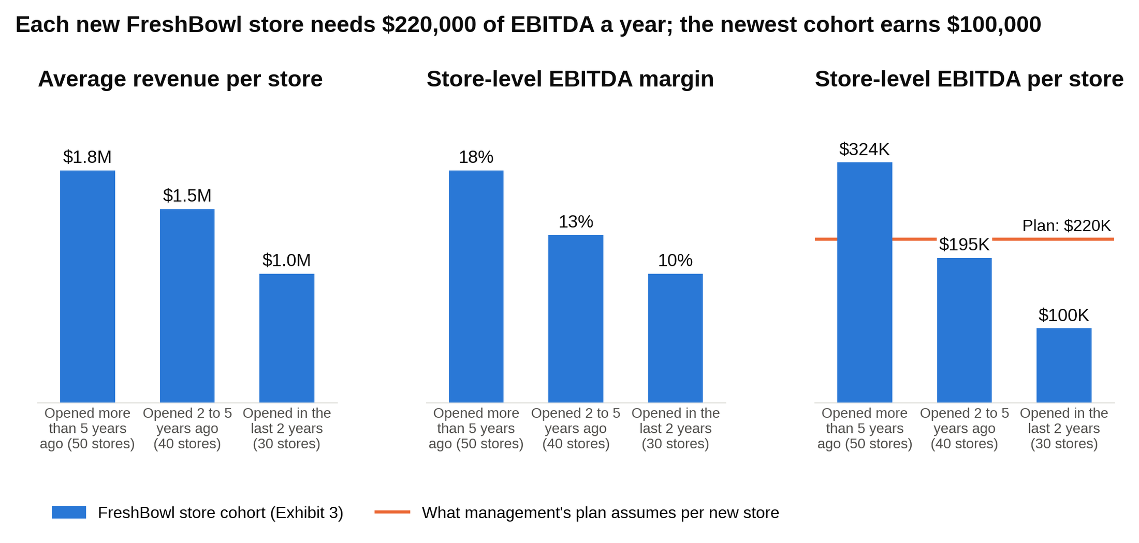
The newest FreshBowl stores earn less revenue at a thinner margin, so each one makes $100,000 against the $220,000 the plan needs.

Before the math, check the exhibit against Exhibit 1. Fifty stores at $1.8 million is $90 million, forty at $1.5 million is $60 million, thirty at $1.0 million is $30 million: $180 million total, which matches. Store EBITDA is $90 million × 18 percent, or $16.2 million, plus $60 million × 13 percent, or $7.8 million, plus $30 million × 10 percent, or $3.0 million: $27 million, which also matches. Checking that a new exhibit ties to the earlier ones takes ten seconds and signals that you read numbers the way a consultant does.

Math question 3: "Rerun the plan using the newest cohort's economics for the 100 new stores."

- New-store revenue: 100 × $1.0 million = $100 million
- New-store EBITDA: $100 million × 10 percent = $10 million
- Existing stores, held flat: $180 million of revenue and $27 million of store EBITDA
- Total store EBITDA: $27 million + $10 million = $37 million
- Company EBITDA: $37 million minus $13 million = $24 million
- Gap to target: $36 million minus $24 million = $12 million short

Then the judgment step that separates candidates. The newest cohort might be weak stores, or it might be young stores still ramping. The middle cohort tells you something: stores two to five years old reach $1.5 million of revenue but only a 13 percent margin, below the oldest cohort's 18 percent. Revenue catching up while margin lags is the pattern you'd expect if newer sites carry higher rent or sit closer to competitors, and it suggests that even a full ramp may not reach the oldest cohort's profit. So run the realistic case too.

Math question 3, second pass: "What if new stores end up looking like the 2-to-5-year cohort by year five?"

- New-store revenue: 100 × $1.5 million = $150 million
- New-store EBITDA: $150 million × 13 percent = $19.5 million
- Total store EBITDA: $27 million + $19.5 million = $46.5 million
- Company EBITDA: $46.5 million minus $13 million = $33.5 million
- Gap to target: $36 million minus $33.5 million = $2.5 million short

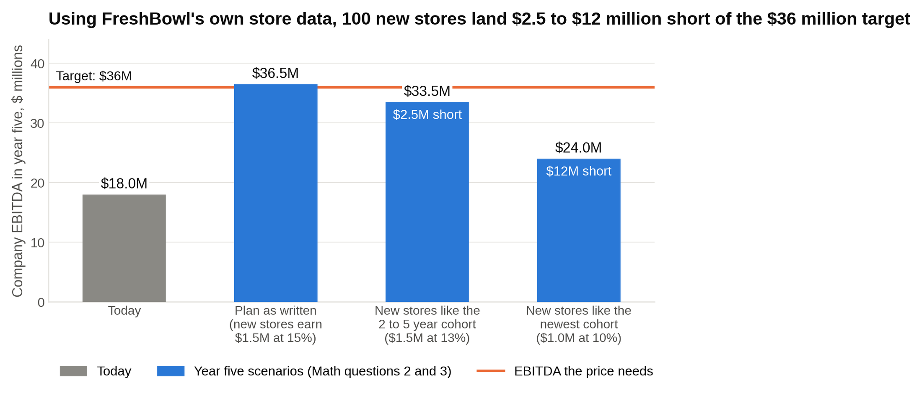
Run the plan on FreshBowl's own cohort numbers and year five EBITDA lands between $24 million and $33.5 million, not $36 million.

The so what: "Using FreshBowl's own store data, 100 new stores get the company to somewhere between $24 million and $33.5 million, not $36 million. Management's plan needs each new store to earn about $220,000 a year in store EBITDA. The oldest stores earn $324,000, the middle group $195,000, the newest $100,000. So the plan only works if new stores grow up to be better than the middle cohort, and the recent trend is the other way."

Math question 4: "What price increase would close the gap?"

A price increase flows almost entirely to EBITDA if customers keep coming, because the lettuce and the labor cost the same whether a bowl sells for $12 or $12.50. Each percent of price adds about one percent of revenue straight to profit, so divide the gap by revenue:

- Realistic case: $2.5 million ÷ $330 million = about 0.8 percent
- Pessimistic case: $12 million ÷ $280 million = about 4.3 percent

The so what: "Price is a real lever. Under one percent closes the realistic gap. But FreshBowl hasn't tested how its traffic responds to price, and a 4 percent increase in a salad chain is not a rounding error. I'd treat price as upside, not as the plan."

The recommendation, answer first, in about a minute:

"I would not buy at the current price. The price needs $36 million of EBITDA, and FreshBowl's own store data says 100 new stores get you to roughly $24 to $33.5 million, a gap of $2.5 to $12 million. Two reasons: new stores open at about $1 million of revenue and a 10 percent margin, well below the $1.5 million and 15 percent the plan assumes, and overhead rises $4 million to run the bigger footprint. The biggest risk to my view is that the newest cohort is simply ramping, in which case the gap is small. So two paths. Renegotiate to a price that works on about $30 million of EBITDA, or spend the last two weeks of diligence on three things: revenue by month since opening for every store, to see the ramp curve; a map of new stores against old ones, to test for cannibalization in the Southeast; and a price test in ten stores. If new stores reach the oldest cohort's numbers inside three years, the deal works at close to the current price."

That close has a verdict, two reasons with numbers, one risk, and next steps. In a final round you'd compress it further; section 7 shows how.

What separates a strong candidate on this case. The average candidate does Math 2, sees $36.5 million, and says the plan works. The good candidate asks for cohort data and does Math 3. The strong candidate does both passes of Math 3, names the ramp-versus-cannibalization question explicitly, and prices the gap. On a Bain diligence case, the candidate who tests the plan's central assumption against the company's own data wins, because that is the job.

7. The answer-first close: a weak one and a strong one, side by side
Theo lost his Bain final on order, not knowledge: analysis first, answer last. That is how a student writes an essay and the opposite of how a consultant briefs a CEO. Bain scores the close hard because the close is what a client hears. Every other MBB firm cares about synthesis too, but Bain's cases, with their diligence framing and their fixed exhibits, give the interviewer a very clear sense of what the right answer was, so a close that wanders is obvious.

The shape of a Bain close, in order:

- The answer. One sentence. Buy, don't buy, enter, don't enter, with the condition if there is one.
- Two reasons, each with a number. The two facts from the case that drove the answer, not everything you learned.
- One risk. The thing that would change your mind, stated as a fact you'd want to check, not as a hedge.
- One next step. What the team does Monday morning.
- Under 45 seconds. Then stop talking.

Here are two closes to the FreshBowl case. Same candidate, same analysis, different order and discipline.

The weak close:

"So, to sum up what we looked at. We started by looking at FreshBowl's current position, where they have 120 stores at $1.5 million each, which gets you to $180 million in revenue, and then with a 15 percent margin and $9 million of overhead that's $18 million of EBITDA. Then we looked at the management plan, which assumes 20 stores a year, and when you run that through you get $36.5 million, so on paper it works. But then the cohort data showed that newer stores are doing $1 million and 10 percent, which is a lot worse, and when you use those numbers you only get to $24 million, although if you use the middle cohort you get $33.5 million, so it kind of depends. There's also the $90 million of capex to think about, and a price increase could help, maybe 1 to 4 percent. So overall I think it's a riskier deal than management is presenting and the fund should probably be cautious, maybe try to get a lower price, and do some more work on the new stores before deciding."

That ran about 185 words and the recommendation arrived in the last clause, hedged twice. A partner hears: this person can do the analysis and cannot tell me what to do.

The strong close:

"Don't buy at this price. The price needs $36 million of EBITDA and FreshBowl's own store data gets you to $24 to $33.5 million, so the plan is $2.5 to $12 million short. Two reasons: new stores open at $1 million of revenue and a 10 percent margin against the $1.5 million and 15 percent the plan assumes, and overhead grows by $4 million. The risk to my view is that the newest stores are just ramping, which would put us at the top of that range. So either renegotiate to a price that works on $30 million, or spend the next two weeks on revenue by month since opening, which tells us whether this is a ramp or a quality problem. If it's a ramp, the deal works close to the current price."

About 135 words, answer in the first four words, every number from the case, one risk, one next step, and a stop. A strong Bain close leads with the verdict, carries two numbers and one risk, and ends before the interviewer wants it to.

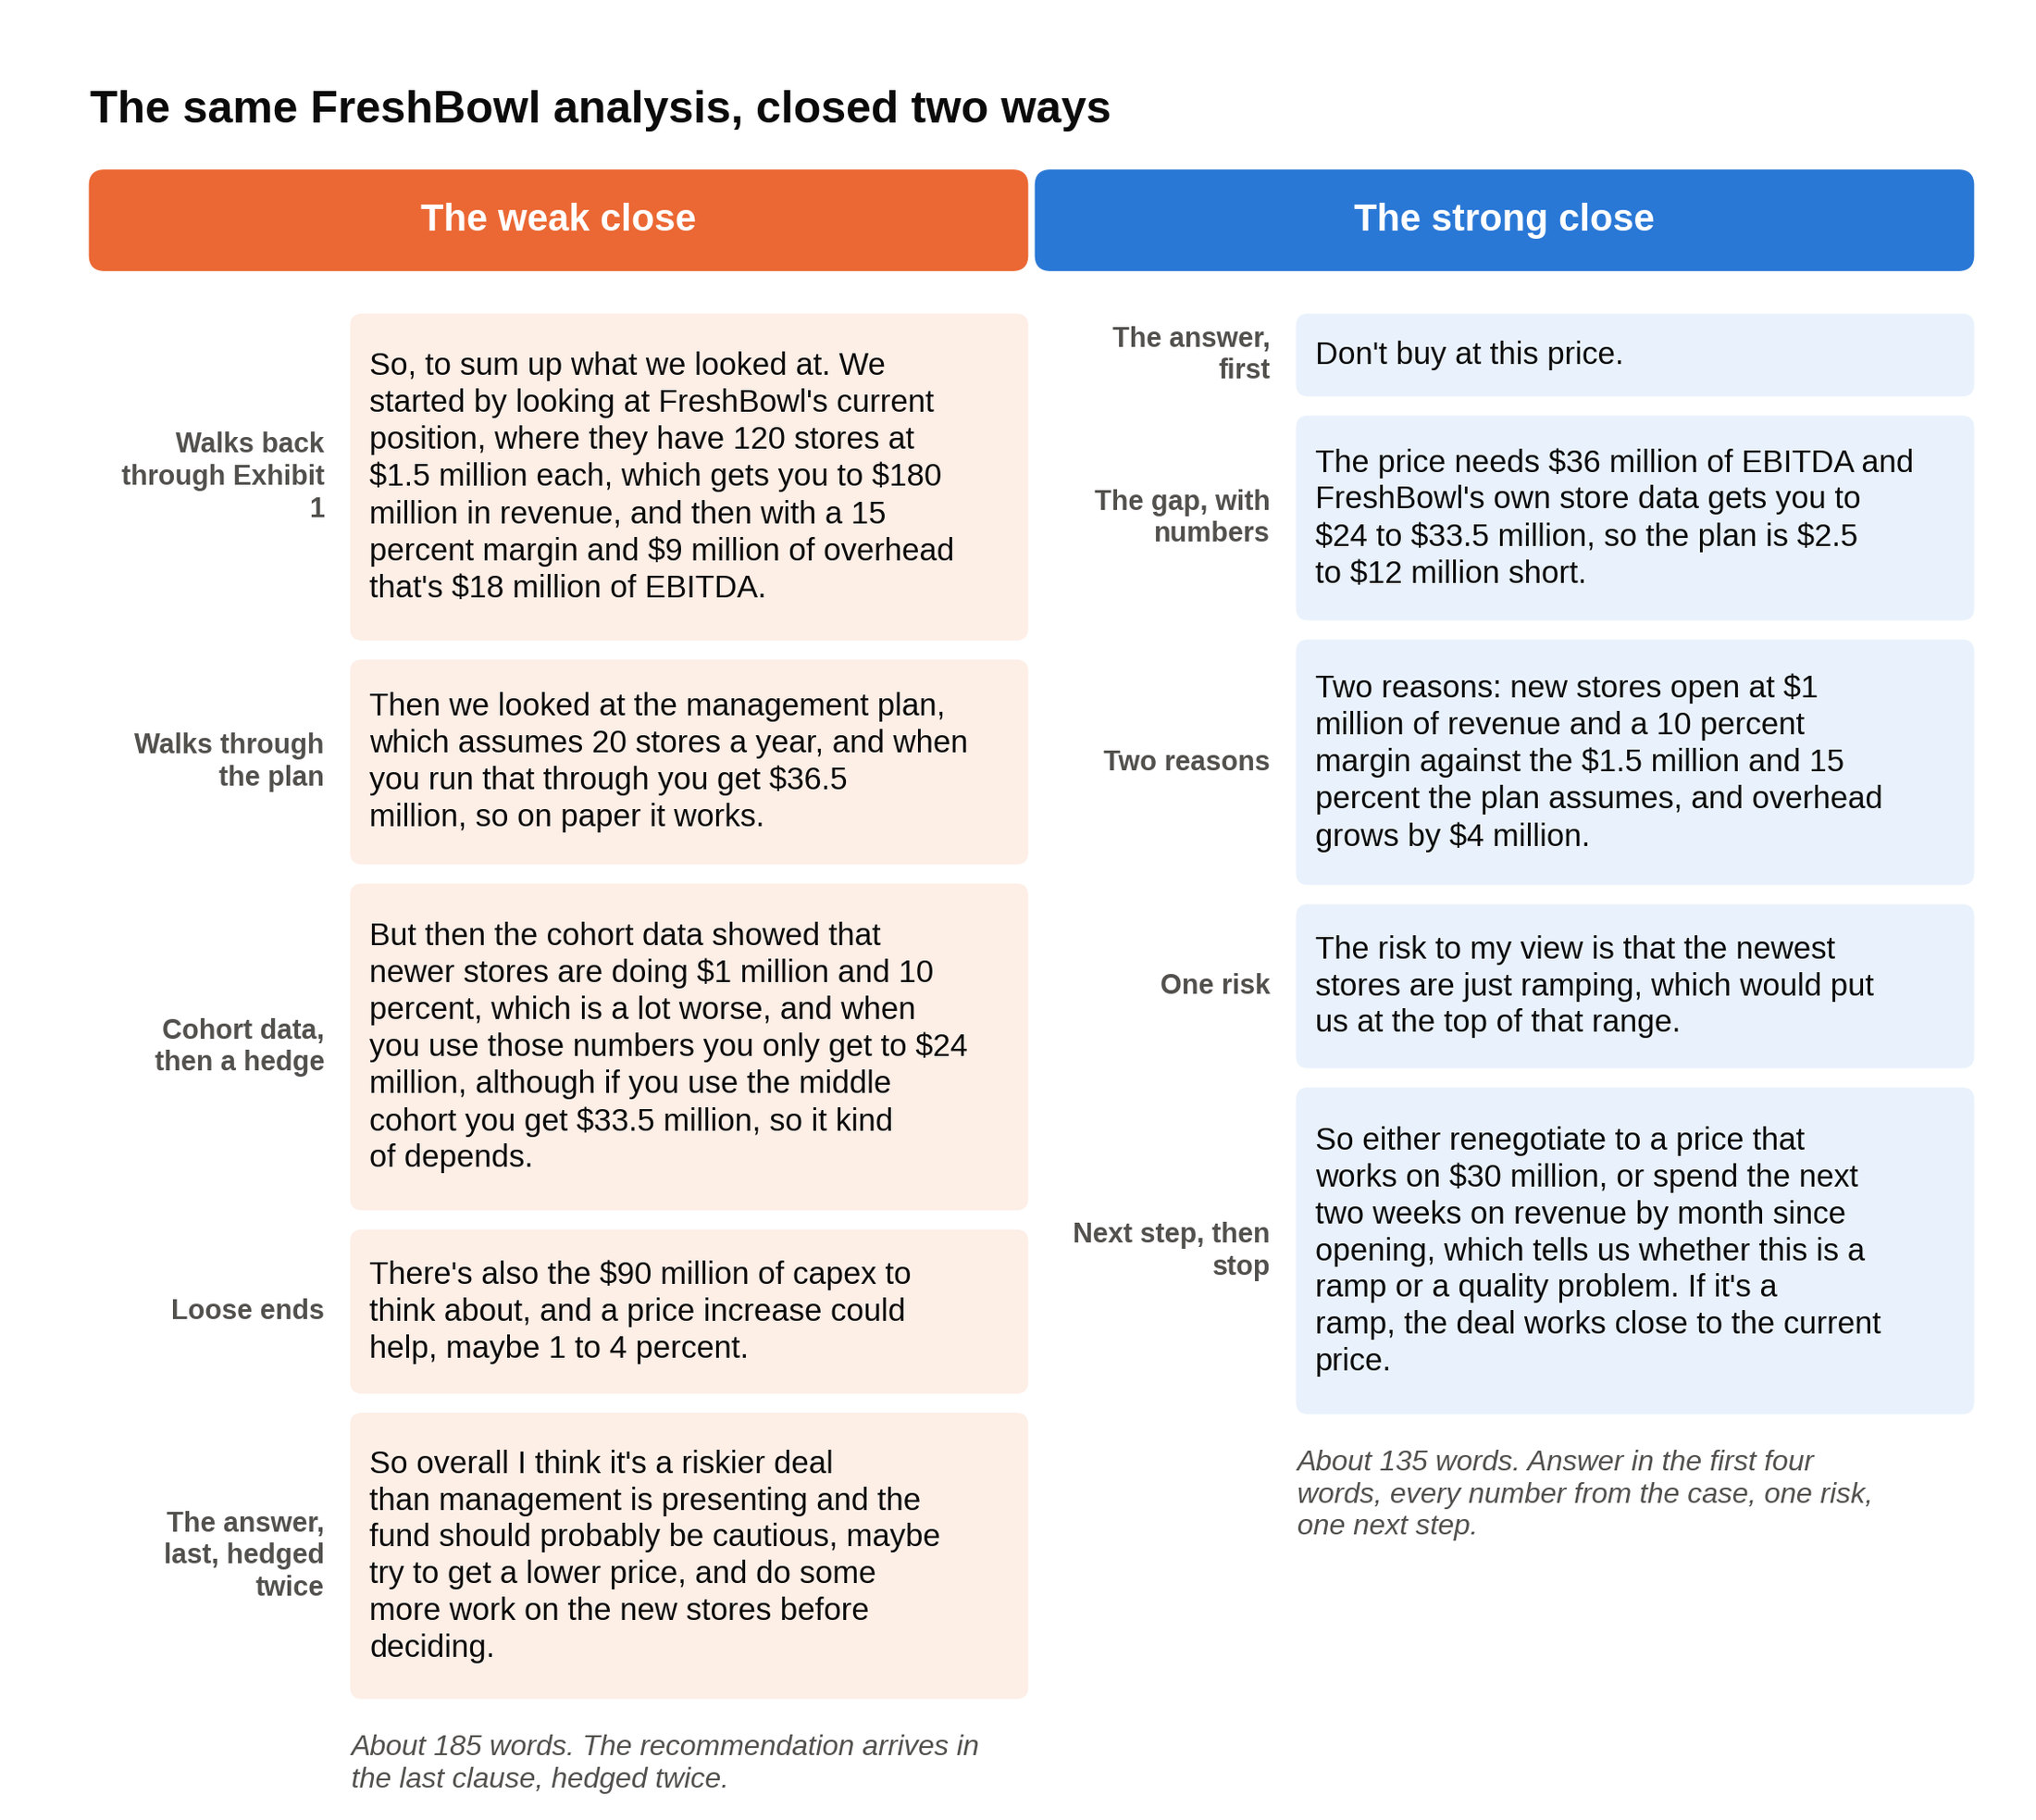
Same candidate, same numbers: the weak close recaps the case and hedges the verdict, the strong close gives it in four words and stops.

How to train it, since it's a separate skill from casing. Take any case you've already done. Set a timer for 45 seconds. Deliver only the ending. Do it again, cutting a sentence each time, until you're under 30 seconds and nothing important is gone. Then do the drill that saved Nadia: have your practice partner stop you mid-case, at random, with "the CEO just walked in," and give the best answer you can from wherever you are. You will be wrong sometimes. The point is that you can produce a verdict from partial information, which is what partners do for a living.

One more thing that drill teaches. If the interviewer stops you at minute 25 and you haven't finished the analysis, say so inside the answer: "Based on what we've seen so far, I'd lean toward not buying, because of X and Y; the thing I'd still want to check is Z." That is a complete answer. "I'd need more time" is not.

8. The written case, step by step
Some Bain offices add a written case to the final round. Candidate reports put it mostly in offices outside the United States, with the format varying by office and cycle: a packet of roughly 20 to 30 slides describing a client's situation, about 55 minutes to read and prepare, three to five slides to complete by hand (often pre-structured templates), then about 40 minutes presenting and discussing with one or two interviewers, no calculator [VERIFY: whether your target office uses a written case and its current format; US offices mostly do not, per candidate reports]. Bain's own interviewing page separately describes a "written assignment" that is a take-home with about three days to complete, which applies to some non-consulting roles. Ask your recruiter which, if either, applies to you. They tell you.

If you get one, here is how to run the 55 minutes. The mistake most people make is trying to read everything. You cannot read 25 slides carefully in under an hour and still write anything, so the job is deciding what to read.

- Minutes 0 to 3: read the question slide and the output template first. Not the data. The question tells you what the answer has to be about; the blank slides tell you what shape it has to take. If the template has a slide titled "Recommendation" and two titled "Supporting analysis," you now know you need one verdict and two charts.
- Minutes 3 to 8: flip through every slide once, fast, and sort. Mark each slide as "moves the answer," "supports," or "scenery." In a typical margin-decline packet, the price and volume exhibit, the cost benchmark against competitors, and the customer or mix data move the answer. The org chart, the store-count history, and the CEO's biography are scenery.
- Minutes 8 to 12: write a hypothesis in one line. "Margin fell because the mix shifted toward lower-margin products and shrink rose, not because of price." You will test it, not defend it.
- Minutes 12 to 35: do the math on the three slides that matter. Round aggressively and say so on the slide. No calculator means every number should be one you can carry in your head.
- Minutes 35 to 50: fill the slides, recommendation first. Write the recommendation slide before the analysis slides, because if you run out of time the recommendation is the one that has to exist.
- Minutes 50 to 55: write message headings. Every slide's title should be a sentence with an implication, not a label. "Gross margin fell 3 points" is a label. "Mix shift and shrink explain most of the 3-point margin decline, so pricing is not the fix" is a message.

A worked mini-example of the triage math, with made-up numbers. Suppose the packet is about a regional grocer with $2 billion of revenue whose gross margin fell from 28 percent to 25 percent. That is $560 million of gross profit falling to $500 million: a $60 million problem. One slide shows private label (the store's own brand) fell from 22 percent of sales to 15 percent, and another shows private label earns a 35 percent margin against 24 percent for branded goods. Hold each category's margin fixed and move only the mix. Before: 22 percent × 35 plus 78 percent × 24 gives a blended margin of 26.42 percent. After: 15 percent × 35 plus 85 percent × 24 gives 25.65 percent. The mix shift alone costs about 0.77 points of margin, which on $2 billion is about $15 million, or a quarter of the decline. A third slide shows shrink (inventory lost to theft, spoilage, and error) rose from 1.5 percent to 2.5 percent of sales: another $20 million, a third of the decline. Those two slides explain about $35 million of the $60 million. The remaining $25 million is where the discussion goes, and saying so on the slide ("about 40 percent of the decline is unexplained by mix and shrink; the next cut is by category") is far stronger than pretending to a complete answer.

Then present it the same way you'd close a live case: answer first, the two or three numbers that support it, the risk, the next step. In the discussion, interviewers push on your assumptions. Treat that as the live case it is, not as a defense of your slides. The written case rewards candidates who read the question before the data, build from the three slides that matter, and write headings that state implications.

9. Bain's own practice cases are the grading rubric, published for free
Bain publishes two full practice cases on its careers site, and both are built the same way: a prompt, a set of guiding questions, the data, and then two model responses labeled "A good answer" and "A better answer." Bain's two practice cases each come with a good answer and a better answer, and the gap between them is the entire lesson. Most applicants never read it.

Coffee Shop Co. asks whether a friend should open a coffee shop in Cambridge, England, a university city of about 100,000 people an hour and a half from London. Bain gives you the price per cup, the opening cost, the annual operating cost, and the cost per cup, and asks for the market size and the breakeven. The good answer works out the breakeven and says whether that share of the market looks reachable. The better answer does that and then asks how long the investment takes to pay back, what makes this shop different from the ones already there, and whether the market is saturated. Same math, but the better answer treats the result as the start of a business decision rather than the end of a calculation.

FashionCo is a revenue-decline diagnosis for a women's fashion retailer with five years of falling sales, and it ends with a choice between two revenue ideas, a rewards program and periodic sales, each with numbers attached. The good answer offers solutions. The better answer prices the options, weighs the pros and cons of each, and raises the practical questions a client would ask before committing.

Here is how to use them, in order:

- Do each case cold, out loud, with a timer, before you read either model answer. Write your own "better answer."
- Read Bain's good answer and mark every place yours matched it. That's your floor.
- Read Bain's better answer and write down, in one line each, what it did that the good answer didn't. You'll find the same three moves every time: it quantified something the good answer left qualitative, it named a risk unprompted, and it ended with a next step.
- Go back to your own answer and rewrite the close with those three moves. Then do the same with every case you practice from any source.

Bain's own YouTube channel has a mock case interview video, a full example with feedback. Watch it once before your first live mock. Bain's pacing is slower and more conversational than the rapid-fire mock cases most students learn from on YouTube, and hearing it resets your sense of how fast you need to talk. Bain's case interview page also points candidates to outside resources (Management Consulted's free prep, a Crafting Cases course, CaseCoach, and a few RocketBlocks cases), which tells you Bain is comfortable with third-party practice as long as you do the thinking yourself. Our own free case prep resources list covers how to use the free ones without wasting a month.

Work Bain's two published cases until you can say why every "better answer" beats its "good answer" twin, because that gap is the scoring rubric.

10. The experience interview decides Bain finals more than at any rival
Bain calls it a behavioral interview on its site; candidates call it the experience interview. The experience interview carries more weight at Bain than at McKinsey or BCG, especially in the final round. Partners there are answering one question: would I staff this person on my team with a client watching?

Some history explains why. Bill Bain was a group vice president at the Boston Consulting Group when Bruce Henderson split BCG into three competing internal teams in 1970; Bain and Patrick Graham ran the blue team. Bain grew frustrated with the model of writing a report and moving on to the next client, and in 1973, after being passed over for succession, he left and founded Bain & Company with a different deal for clients: longer relationships, one client per industry so the firm never worked for a client's competitor, and consultants who stayed to help implement the advice rather than handing over a report [VERIFY: founding history per Wikipedia and Bain's own materials]. Bain's values page still says that clients should get results from their consultants rather than recommendations alone. The word "Bainie," by the way, started as a jab from outsiders and was adopted inside the firm as a compliment.

A firm that promises to stay and implement needs consultants who work as a team on the same client for years, not individuals who write a report and leave. That is where the team culture comes from. The firm's operating principle, which it publishes and discusses in its own Beyond the Bio podcast episode, is "a Bainie never lets another Bainie fail." Interviewers hire for that. Bain has also sat near the top of Glassdoor's Best Places to Work list for years: number one in 2025 for a record seventh time, eighth on the 2026 list [VERIFY: Glassdoor rankings update each January].

What that means for your stories:

- End every story on the effect you had on other people. The team that finished, the club member who stepped up because you changed how the meeting ran, the client who got what they needed. Solo-hero stories, even impressive ones, play worse here than at McKinsey, where personal impact is one of the scored dimensions.
- Have one failure story you actually learned from. Partners at Bain ask for it more than their peers do, and the weak version ("I learned to manage my time better") is instantly recognizable. The strong version names what you got wrong, what it cost someone else, and what you do differently now, with an example.
- Prepare five or six stories, not twelve. Teamwork under pressure, leading people who didn't report to you, a result you drove with numbers, a failure, a conflict you resolved, and a time you changed your mind. Each should run two minutes and survive a follow-up.
- Know why Bain, specifically. Not culture compliments. Partners hear their own values quoted back at them all day. The strong answer names a piece of Bain's work (a published practice case, a report, a conversation with an AC) and connects it to something concrete you want to do. For Bain, make the specific detail about private equity work, implementation, or a named practice.

Bain partners hire people they would want on their own case team, so every fit story should end with what changed for the people around you.

11. The Summer 2028 calendar, the sophomore doors, and the paycheck
Bain recruits its junior-summer interns about fifteen months ahead, so sophomores apply in 2027 for Summer 2028 seats. For Summer 2027 Associate Consultant Intern roles, the two US application deadlines fell on March 29 and August 31, 2026, both for students graduating between December 2027 and June 2028. Those windows are closed. As of October 1, 2026, Bain's ACI page still describes the closed cycle (it asks for students "on track to graduate by June 2028") and says only that exact deadlines vary by office, and the school pages say applications "typically open in the spring" [VERIFY: Summer 2028 ACI postings on bain.com and your school's Bain page].

So the cycle that matters if you're a sophomore today (Class of 2029) is applications in 2027 for Summer 2028 internships. Working from last cycle's shape:

What | Who | When to expect it | Status
Consulting Kickstart | Sophomores at four-year US and Canadian schools; three-part virtual webinar series in October | Application deadline Monday, October 5 at 11:59 pm Pacific; Bain's page shows the day without the year, and October 5, 2026 is a Monday | Open now [VERIFY: Consulting Kickstart page]
CREW (Connecting and Resourcing Empowered Women) | Sophomore women; a short in-person program with women leaders at Bain across 15 US and Canadian offices | 2026 program closed; 2027 cycle not yet posted; last cycle's applications ran in the fall and winter | Watch the page [VERIFY: 2027 CREW dates]
BEL (Building Entrepreneurial Leaders) | Sophomores; a short exploratory program across 14 US and Canadian offices, founded 2009 | 2026 program closed with an early February deadline; 2027 cycle not yet posted; expect applications around January 2027 | Watch the page [VERIFY: 2027 BEL window]
First Forward | Sophomores who are first-generation or grew up lower-income; a 1.5-day summit at six US offices, with an ACI application the following summer | Summit ran May 28 and 29; next cycle expected spring 2027 | Closed, check back [VERIFY: 2027 First Forward dates and eligibility]
BASE (Building and Supporting Excellence) | Pre-MBA students in Bain's wording; a week-long BASE Camp across 13 US offices | 2026 closed; Bain says to check back in spring for the 2027 program | Closed [VERIFY: 2027 BASE]
Associate Consultant Intern (Summer 2028) | Juniors in Summer 2028, graduating December 2028 to June 2029 | Expect a first deadline around spring 2027 and a second around late summer 2027, matching the 2026 pattern | Not yet posted [VERIFY: dates when announced]
Associate Consultant, full time | Seniors graduating December 2026 to June 2027 | October 11, 2026 on Bain's Harvard school page | Open now [VERIFY: your school's Bain page]

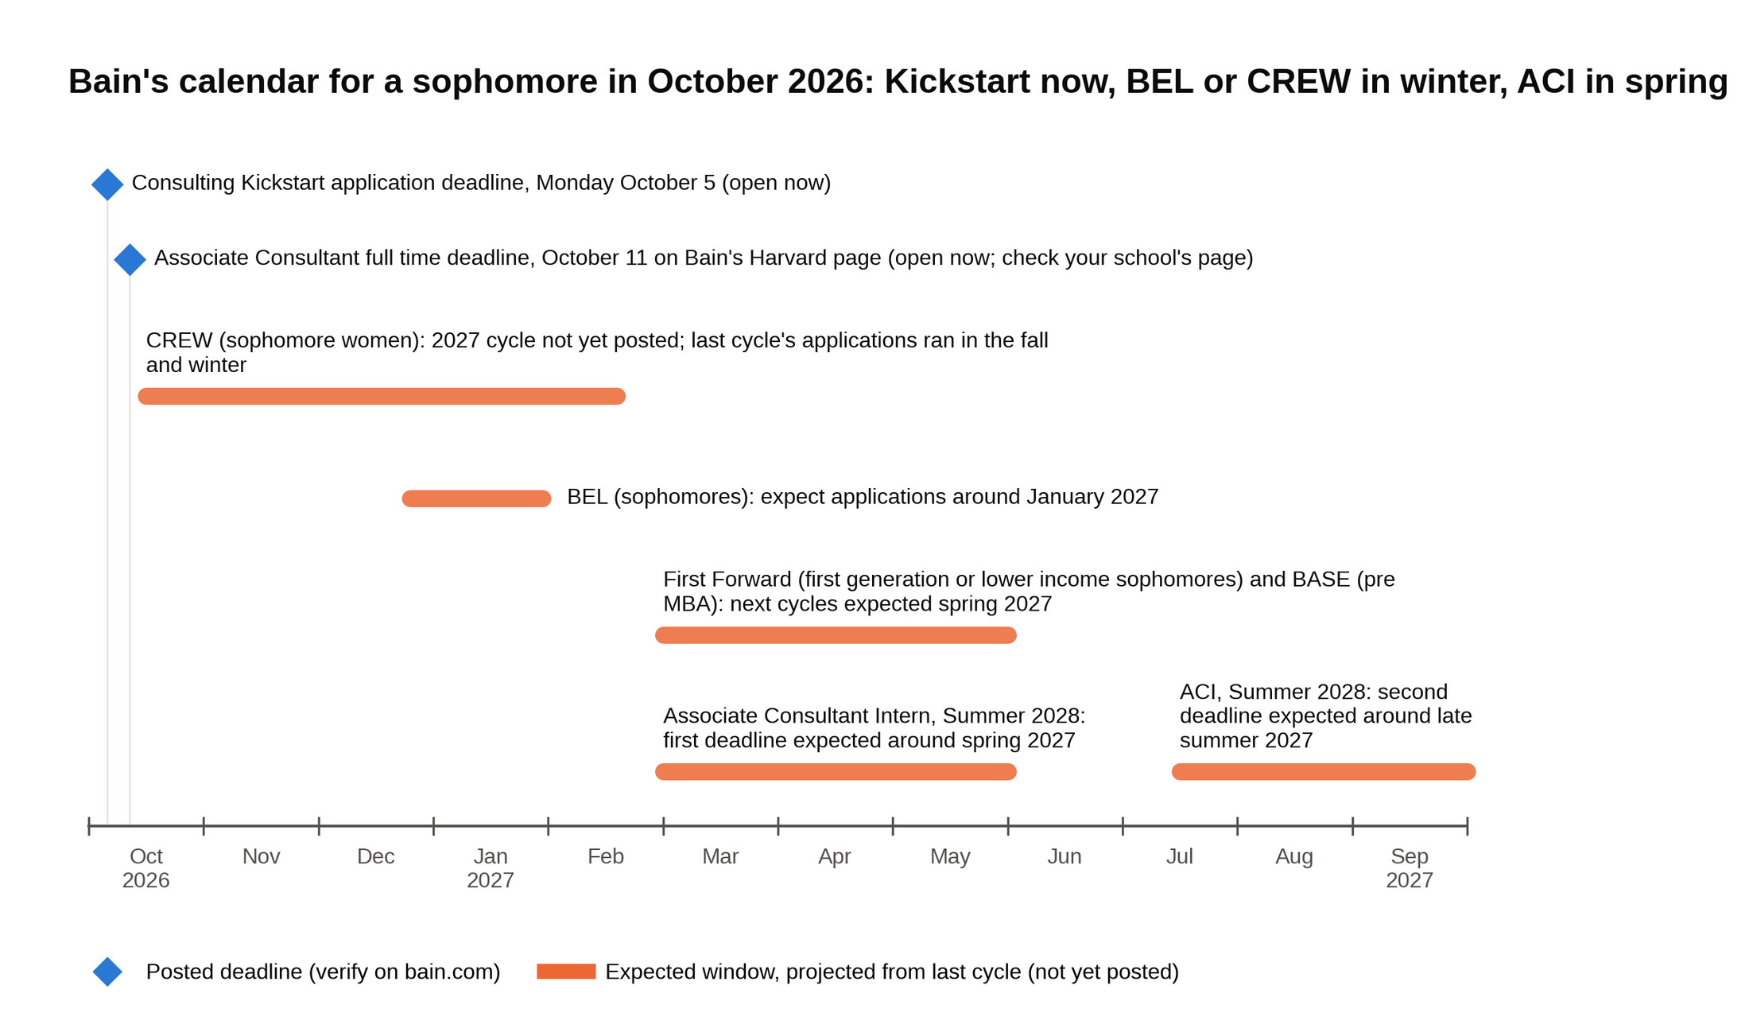
Consulting Kickstart closes this week, BEL and CREW come in the winter, and the first Associate Consultant Intern window is expected in spring 2027.

Three notes on that table. Consulting Kickstart is new to Bain's US program list and it's the one with a deadline this week; it's a webinar series, not an interview pipeline, but Bain says it is "intentionally designed to help you build a strong foundation for future Bain recruiting processes," and showing up to the firm's own sophomore programming is how you get a name in the system a year before ACI applications open. BEL and CREW are exploratory programs of a day or two, not internships; older prep guides call Bain's sophomore program "Bain Build," and no program by that name exists. And apply in the first ACI window you're eligible for. Our consulting recruiting timeline covers why first windows fill most of the interview slots across MBB.

Pay, since you'll be asked whether it was a factor. US Associate Consultants earn a $112,000 base with a performance bonus of up to $22,500, a signing bonus of up to $5,000, and a relocation bonus of up to $5,000, per Management Consulted's salary data, and Bain's own Associate Consultant Intern page lists intern pay at $9,000 a month, prorated over the summer [VERIFY: current-cycle comp figures against bain.com and the salary trackers]. That matches McKinsey and BCG to within rounding, so choose between the three on the staffing model and the culture, not the base.

For a sophomore reading this in October 2026, Bain's calendar runs Consulting Kickstart now, BEL or CREW in the winter, and the first ACI window in spring 2027.

12. A four-week prep plan that fits around a full course load
Four weeks, about ten to twelve hours a week. This assumes you've read what a case interview is and have one practice partner. If you don't have a partner, your school's consulting club is the fastest fix; failing that, the bigger free case libraries have partner matching built in.

Week 1: calibrate.

- Read bain.com's hiring, assessment, and case pages end to end. Thirty minutes.
- Watch Bain's mock case video once, then do Coffee Shop Co. cold and out loud, with a timer. Read the good and better answers only afterward and write your three-line gap list.
- Daily: 20 minutes of mental math with a chart. Percentages, growth rates, breakeven.
- Two live cases with your partner, one profitability and one market sizing. Record them on your phone. Listen back for how long you took to say anything after each exhibit.

Week 2: structure and judgment.

- Do FashionCo the same way. Then rebuild the FreshBowl case from section 6 with your own numbers and have your partner run it on you.
- Three live cases, at least one framed as a diligence question ("our PE client wants to buy this; is the plan believable?"). After each exhibit, force yourself to say the "so what" before the math.
- Start the synthesis drill: ten 45-second closes a day from cases you've already done.
- Draft five experience stories. Two minutes each. End each one on the effect on other people.

Week 3: pressure.

- Four live cases, with your partner instructed to interrupt you once per case with "the CEO just walked in." Give the answer from wherever you are.
- One case done as a written case: a 20-slide deck from any case library, 55 minutes, three slides by hand, present in 15. If your target office doesn't use a written case this still trains triage.
- Record one full mock, case plus experience questions, and watch it with the sound off. Note every time you look at the ceiling instead of the interviewer.
- Mental math continues. If you're still slow on percentage changes, this is the week to fix it.

Week 4: polish and rest.

- Two live cases early in the week, both with a stranger if you can arrange it (a club alumnus, a friend's friend). Strangers don't fill in your gaps for you.
- Tighten the "why Bain" answer to 60 seconds with one specific detail.
- Reread your gap lists from Coffee Shop Co. and FashionCo. The three moves of a better answer should be automatic by now.
- Two days before: nothing. One day before: one easy case, the synthesis drill, early night.

About a dozen live cases, plus Bain's two published cases and one written practice, is the range that survives a partner round. This plan lands most candidates there. Four weeks of Bain prep is enough if a third of it goes to the close and the experience stories, which is where most candidates give the firm nothing to score. Our 10 tips for the case interview article covers the habits that transfer across firms.

13. The mistakes that lose Bain finals
Each of these has cost someone a Bain offer, Theo included.

- Delivering the analysis before the answer. The most common Bain-specific loss. Fix: the synthesis drill in section 7, every day for two weeks.
- Describing an exhibit instead of interpreting it. "This chart shows revenue by store age" is a caption. "New stores earn a third less, so growth is coming from count, not quality" is an insight. Interviewers write down the second kind.
- Computing before setting up. A wrong number that arrives in silence is a lost minute and a lost point. The same wrong number said as "fifteen percent of 180, so 27" gets corrected before it compounds.
- Treating round one like a freeform case. Fighting for your own path through a standardized packet wastes time and reads as not listening. State your hypothesis, then work the exhibits you're given.
- Solo-hero experience stories. A story that ends with your award and never mentions the team tells a Bain partner exactly what they didn't want to hear.
- Culture compliments as the "why Bain." Interviewers hear "the people" ten times a day. Name a piece of work.
- Hedging the recommendation. "Probably," "maybe," and "it depends" in the close are the verbal equivalent of Theo's three-minute walk back through his structure. Commit, then name the risk.
- Skipping the assessment prep. One week. Not zero, not three.

Most lost Bain finals come down to order and commitment in the last two minutes, not to knowledge.

Say this, don't say that in a Bain interview
When the interviewer hands you an exhibit

Don't say: "So this chart is showing store revenue broken down by how old the stores are, with three categories."

Say: "The newest stores earn about a third less than the oldest, so the growth plan is leaning on store count, not store quality. I'd want to know if that's a ramp or a trend before I believe the year-five number."

When you're asked to do the math

Don't say: (silence for forty seconds, then) "27 million."

Say: "Fifteen percent of 180 million. So 27 million of store-level EBITDA, and after the 9 million of overhead, 18 million for the company."

When the partner says "the CEO just walked in"

Don't say: "Sure. So we started by looking at the current position, and then we looked at the growth plan, and then the cohort data showed..."

Say: "Don't buy at this price. The plan needs 36 million and the store data gets you to 24 to 33 and a half. The risk to that view is that new stores are still ramping, so the next two weeks go on revenue by month since opening."

Why Bain?

Don't say: "Bain's people and culture really set it apart for me, and everyone I've talked to loves it there."

Say: "I worked Bain's FashionCo case, then asked an AC in your consumer practice how real retail diligence compares. She walked me through a three-week due diligence sprint for a private equity client, and that specific work, testing whether a plan holds up before someone pays for it, is why Bain is first for me."

Tell me about a time you failed

Don't say: "I took on too much sophomore year and learned to manage my time better."

Say: "I ran our club's spring conference and booked the venue before confirming sponsors, so when two dropped out we were $4,000 short and I had to ask members to cover costs. Now I don't commit money I don't have, and for this year's event I locked sponsorships six weeks before the venue deposit."

How many practice cases have you done?

Don't say: "Probably fifty or sixty."

Say: "A semester's worth with two partners, plus Bain's two published cases, which I used to figure out what a better answer looks like compared to a good one."

What to do this week
If you're a sophomore: apply to Consulting Kickstart before Monday's deadline [VERIFY: Consulting Kickstart page], put BEL and CREW on your calendar for the winter, and book your first live case mock. The ACI window you'll apply in is spring 2027, which sounds far away and is about 25 weeks of real prep time once you subtract exams and holidays.

If you're a senior: the full-time Associate Consultant deadline on your school's Bain page is in October, so the four-week plan starts today, and the first thing it starts with is the close.

Either way, work Bain's two published cases this week and write your 45-second synthesis for each. The firm has told you, in writing, what a better answer looks like. Most of your competition will never read it. Our MBB guide covers the rest of the three-firm picture when you're ready for it.

